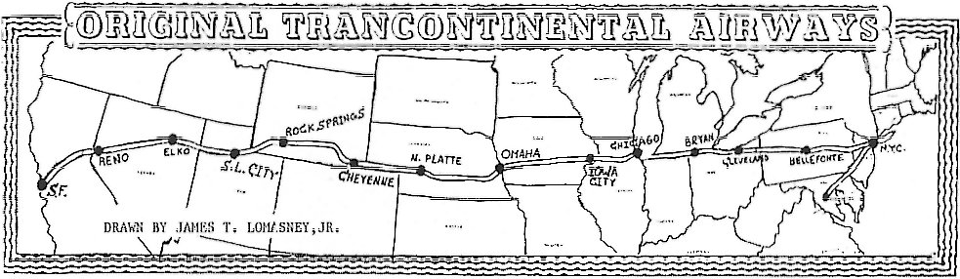
UNITED STATES AIR MAIL SERVICE
PILOTS' DIRECTIONS
NEW YORK to SAN FRANCISCO ROUTE
DISTANCES, LANDMARKS, COMPASS
COURSE, EMERGENCY AND REGULAR
LANDING FIELDS, WITH SERVICE AND
COMMUNICATION FACILITIES AT
PRINCIPAL POINTS ON ROUTE

Post Office Department,
Office of Assistant Postmaster General,
Division of Air mails.

WASHINGTON
GOVERNMENT PRINTING OFFICE
1921
These flying directions and the ground information were prepared with the cooperation of pilots and supervisory officials of the Air Mail Service and with the assistance of the postmaster located within 5 miles of the line of flight. All employees of the Air Mail Service will be required to familiarize themselves with the information relating to the section of the route with which they are concerned.
Otto Praeger, Second Assistant Postmaster General
Washington, D.C.
February 20, 1921

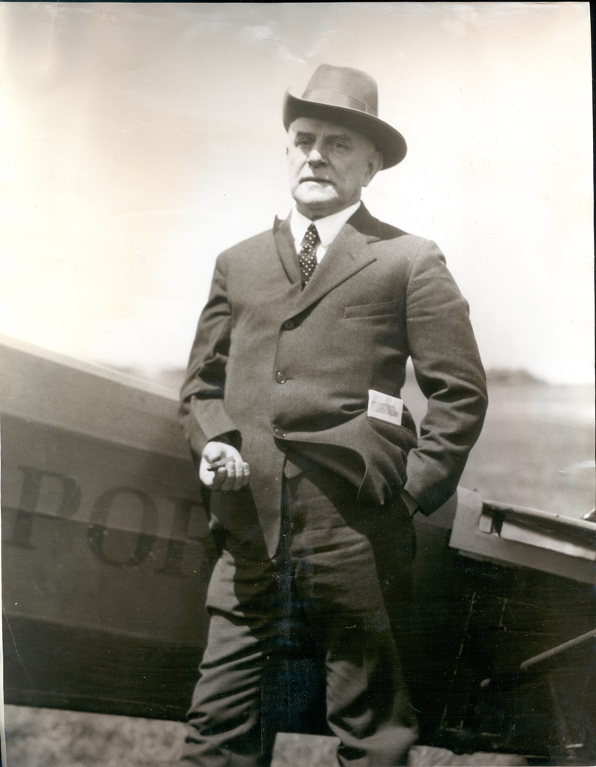
Otto Praeger was the second assistant postmaster general from 1915-1921 and was in charge of the Post Office Department's airmail service (1918-1927) during its early years. He butted heads with the service's first superintendent, Benjamin Lipsner, a fight that resulted in Lipsner's dismissal from the service. Praeger's hard line towards the pilots helped set a strike in motion in 1919 after he had ordered pilots fired for refusing to fly in zero visibility fog. The pilots won public support during the strike and most were rehired. Praeger turned his stubborn streak toward Congress, battling for financial support for the service. National Postal Museum, Curatorial Photographic Collection Photographer: Unknown.
TRANSCONTINENTAL AIR MAIL
PILOT'S LOG OF DISTANCES, LANDMARKS & FLYING

NEW YORK TO BELLEFONTE
Miles from New York
0. Hazelhurst Field. — Long Island, N.Y.--Follow the tracks of the Long Island Railroad past Belmont Park- race track, keeping Jamaica on the left. Cross New York over the lower end of Central Park.
Hazelhurst Field [40.74N / 073.6W] Was created in 1915 as Hempsted Plains Aerodome, the airfield was taken over the by the Army and renamed Leighton Hazelhurst (the first NCO killed in an aviation accident) when the US entered WWI in the spring of 1917. Camp Albert L. Mills with two airfields, Aviation Field #1 and #2, were created to train military pilots. Field #1 was renamed Quentin Roosevelt Field in 1918 after Theodore Roosevelt’s son who was killed in air combat during the War. After the war the field turned over to the US Air Service who relinquished control in 1920 but the field remained the New York terminus of the airmail service.
Because of it’s proximity to New York City, Roosevelt Field was used for most of the aviation events in the early half of the century including Amelia Earhart, Wiley Post and Charles Lindbergh’s 1927 transatlantic flight. It was closed in 1951 and became the sight of the first shopping mall built in the US.
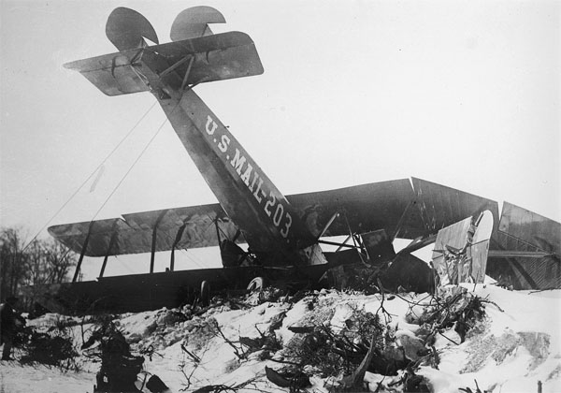
25. Newark, N.J. — Heller Field is located in Newark and may be identified as follows: The field is 1-1/4 miles west of the Pasaic River and lies in the New York, Lake Erie & Western Railroad. The Morris Canal bound the western edge of the field. The roof of the large steel hanger is painted an orange color.
25. Orange Mountains. — Cross the Orange Mountains over a small round lake or pond. Slightly to the right of course will be seen the polo field and golf course of Essex Country Club About 8 miles to the north is Mountain Lake, easily seen after crossing the Orange Mountains.
Figure 1-1920 Crash of Martin MP 203 [Skyways Journal Magazine]
50. Morristown, N.J. — About 4 miles north of course. Identified by group of yellow buildings east of the city. The Delaware, Lackawanna & Western Railroad pass the eastern side of Morristown.
60. Lake Hopatcong. — A large irregular lake 10 miles north of course
64. Budd Lake. — Large circular body of water 6 miles north of course.
78. Belvidere, N. J. — On the Delaware Rv. Twelve miles to the north is the Delaware Water Gap and 11 miles to the south is Easton at the junction of the Lehigh and Delaware Rivers. The Delaware makes a pronounced U--shaped bend just north of Belvidere. A railway joins the two ends of the U
111. Lehighton, Pa. — Directly on course. The Lehigh Valley and Central Railroad of NJ running parallel pass three miles through Lehighton. The Lehigh River runs between the railroads at this point. Lehighton is approximately half way between Hazelhurst and Bellefonte. A fair sized elliptical race track lies just southwest of town but a larger and better emergency landing field lies about 100 yards west of the race track. The field is very long and lies in a north south direction.
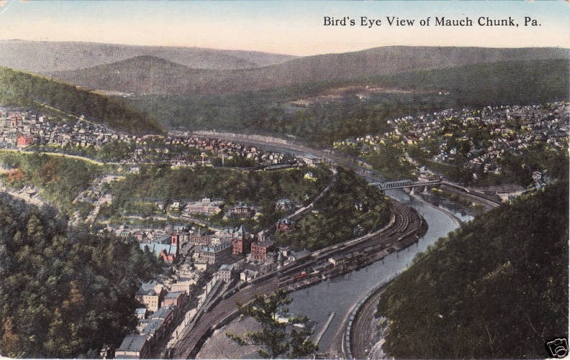
114. Mauch Chunk, Pa. — Three miles north of Lehighton and on the direct course.
Mauch Chunk PA is now home to the Mauch Chunk Switchback Gravity Railroad, generally acknowledged as the first roller coaster in the United States. In 1951 The town merged with East Mauch Chunk and renamed itself Jim Thorpe, PA in hopes of drawing tourists.
121. Central Railroad of New Jersey. — Two long triangular bodies of water northwest of the railroad followed by eight or nine small artificial lakes or ponds about half a mile apart almost parallel with the course but veering slightly to the south.
148. Catawissa Mountain Range, which appears to curve in a semicircle about a large open space of country directly on the course. To the north of the course may be seen the eastern branch of the Susquehanna. Fly parallel to this until Shamokin Creek is picked up. This Creek is very black and is paralleled by two railroads. Shamokin Creek empties into the Susquehanna just below Sunbury.
168. Sunbury, Pa. — At the junction of the two branches of the Susquehanna River. The infield of a racetrack on a small island at the junction of two rivers furnishes a good landing field. The river to the south of Sunbury is wider than to the north and is filled with numerous small islands. The two branches to the north have practically no islands. If the river is reached and Sunbury is not in sight look for islands. If there are none, follow the river south to Sunbury. If islands are numerous, follow the river north to Sunbury.
170. Lewisburg, Pa. — Two miles west of Sunbury and 8 miles north.
174 After leaving Sunbury the next landmark to pick up is Penns Creek. Which empties into the Susquehanna 7 miles south of Sunbury. Flying directly on course. Penns Creek is reached 6 miles after it joins the Susquehanna 7 miles south of Sunbury.
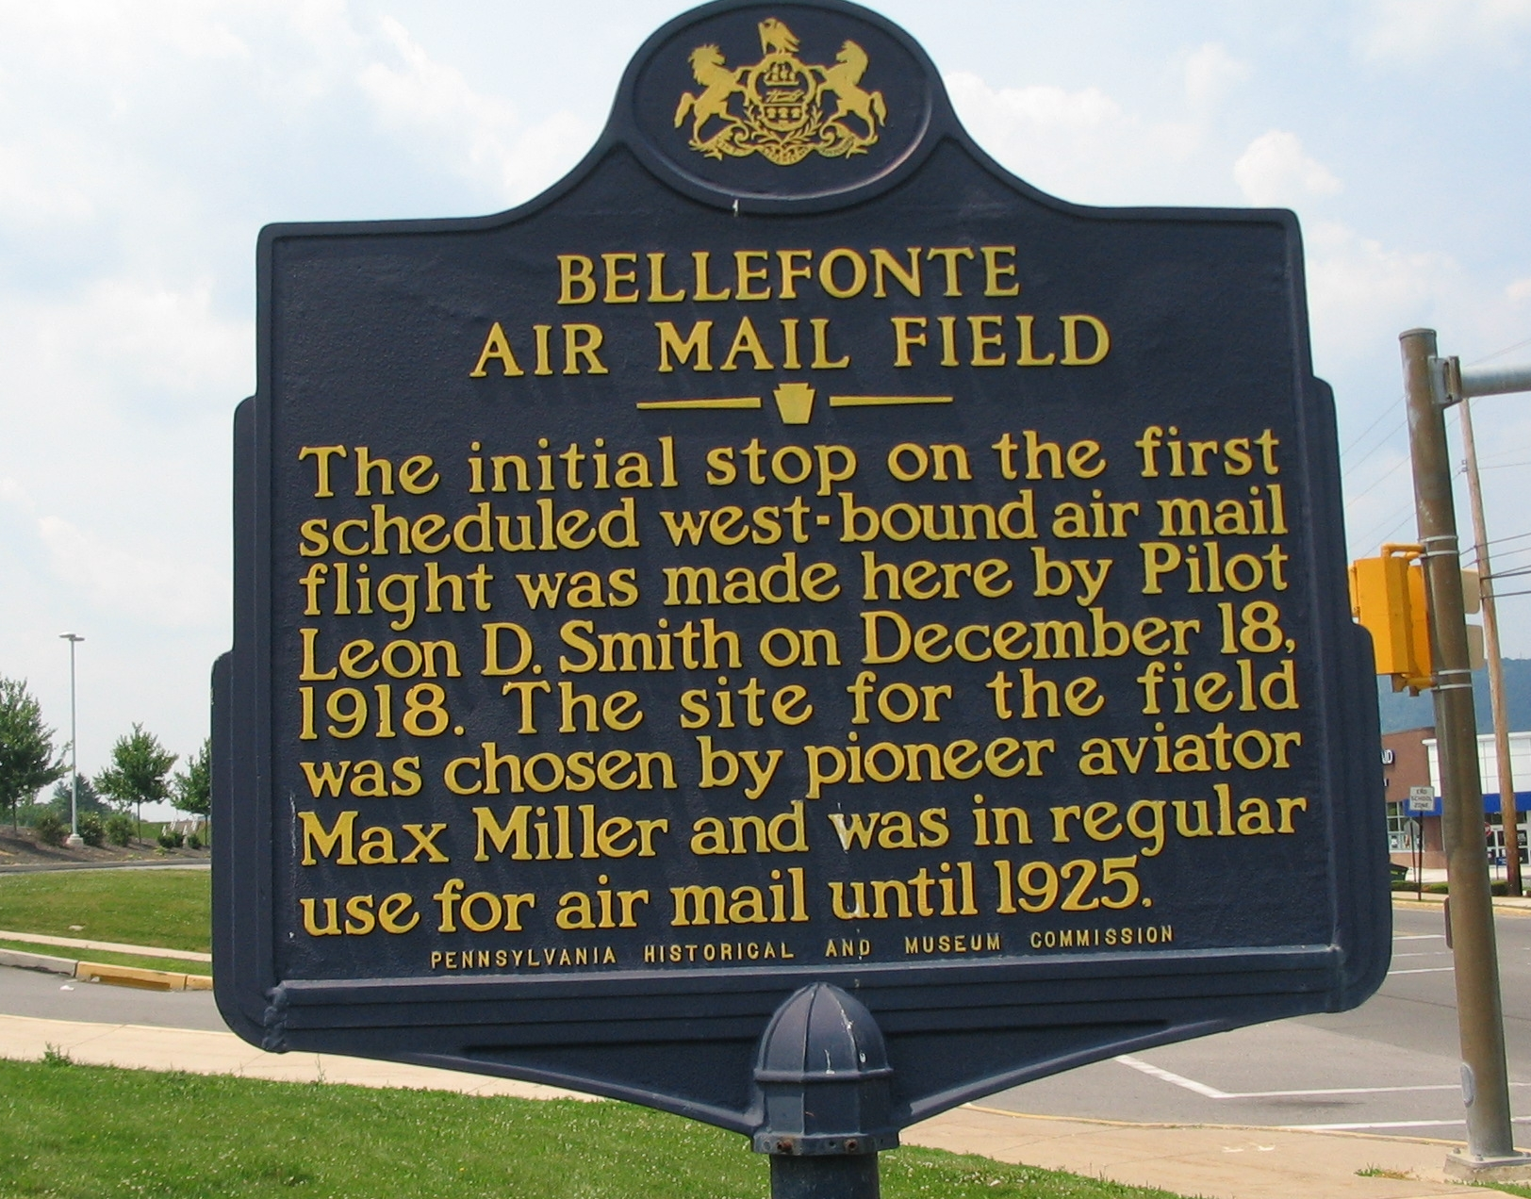
178. New Berlin, Pa. — Identified by covered bridge over Penns Creek.
185. The Pennsylvania Railroad from Lewisburg is crossed at the point where the range of mountains coming up from the southwest ends. The highway leaves the railroad here and goes up into Woodward Pass, directly on the course. A white fire tower may be seen on the crest of the last mountain to the north on leaving the pass.
202. The next range of mountains is crossed through the pass at Millheim, a small town. A lone mountain may be seen to the south just across the Pennsylvania tracks.
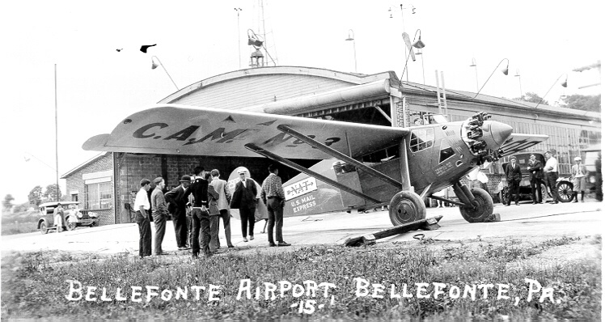
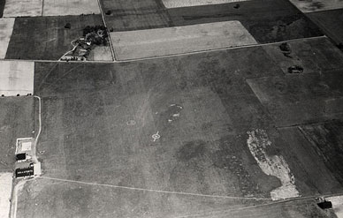
217. Bellefonte, Pa. — After crossing another mountain range with a pass Bellefonte will be seen against the Bald Eagle Mountain Range. On top of a mountain, just south of a gap is the Bald Eagle Range at Bellefonte, may be seen a clearing with a few trees scattered in it. This identifies this gap from others in this range. The mail field lies just east of town and is marked by a large white circle. A white line marks the eastern edge of the field where there is a drop of nearly 100 feet.

BELLEFONTE TO CLEVELAND.
Miles from Bellefonte
BEL + 0. Bellefonte, Pa. — Compass course to Cleveland approximately 310. Fly directly toward and over bare spot on mountaintop south of gap in Bald Eagle Range. First range of mountains.
BEL + 3. Pennsylvania Railroad, following course of Bald Eagle Creek.
BEL + 17. New York Central Railroad, following course of Moshannon Creek.
BEL + 35. Clearfield, Pa. — On west branch of Susquehanna River. A small racetrack here serves as an emergency landing field. Two railroads, one from the north and one from the east, enter Clearfield and both go south from here.
BEL + 55. B. & M. Junction. — One branch of the Buffalo, Rochelle & Pittsburgh from the east forms a junction here with the N. & S. line of the Buffalo, Rochelle & Pittsburgh Railroad. Dubois is 2 miles north of course on the N. & S. line of the railroad.
BEL + 70. Brookville, Pa. — One mile north of course, west of city, is 2-mile racetrack, which makes an excellent emergency field.
BEL + 86. Clarion, Pa. — One mile north of course. Emergency field marked by white cross and red-brick hangar is here. The Clarion river passes north edge of city. Railroad from the east ends here
BEL + 110. Franklin, Pa.-Seven miles north of course at junction of Allegheny River and French Creek. Cross Allegheny River where there is a pronounced horseshoe bend. This is due south of Franklin.
BEL + 122. Sandy Lake, PA. — Two miles north of course. Cross the Pennsylvania Railroad at right angles 2 miles south of Sandy Lake.
BEL + 138. Shenango. — Two miles north of course. Three railroads enter this town from the north. Two continue south and one runs east for 3 miles and then turns southeast.
BEL + 152. New York Central Railroad - running north and south. One mile north of course the Erie crosses the New York Central at right angles. Four miles west of Erie should be crossed where it turns southward. Eight miles south of course is Warren with eight railroads radiating out.
BEL + 157. Pennsylvania Railroad, running north and south.
BEL + 165. Baltimore & Ohio Railroad, Running diagonally northeast-southwest.
BEL + 206. Cleveland on Lake Erie. — The mail field is in East Cleveland between the two railroads that follow the lakeshore. The field is near the edge of the city and near the edge of the freight yards of the New York Central. The field is distinctly marked by long cinder runway. The airmail hangar is in the southwest corner of the field. The Martin factory is in the northwest corner of the field.

CLEVELAND TO CHICAGO
Miles from Cleveland
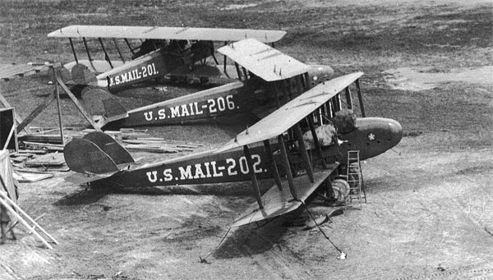
CLE + 0. Martin Field, Cleveland. — Fly a little west of south for nearly 10 miles or about seven minutes flying and then due west, thus keeping over good emergency landing fields. The country between Cleveland and Chicago is divided into sections, section lines running due north and south and east and west. For the first 15 miles the lake shore is only a few miles north of the course.
Figure 2-Martin MP airplanes await delivery outside the Martin Cleveland factory. (John A. Eney private collection)
Martin Field - 16800 St. Clair Ave, Cleveland Ohio. Behind the Glenn L. Martin Co aircraft plant.
CLE + 20. Elyria, Ohio. — Five miles south of course. Five railroads radiate out of Elyria.
CLE + 37. Vermilion, Ohio. — Two miles north of the course. On Lake Erie. The New York Central Railroad follows the shore line of the lake from Vermilion to Sandusky.
CLE + 55. Sandusky, Ohio. — Five miles north of the course on Sandusky Bay, a large irregular body of water crossed by the New York Central Railroad. Continues due west from this point, following the east-west section lines.
CLE + 112. Maumee River. — which you cross about 5 miles northeast of Grand Rapids and 5 miles south of Waterville. Waterville is on the east bank of the Maumee and Grand Rapids is on the south bank of the river where it turns east and parallels the course for 7 miles.
CLE + 130. Detroit, Toledo & Ironton Railroad, crossed at right angles. Wausen [Wauseon], Ohio is 7 miles north of the course and Napoleon is 5 miles south, both on the above-mentioned railroad. By flying about 11 miles north from the point where the Maumee River is crossed and then due west the New York Central four-track railroad will be picked up just before reaching Bryan.
CLE + 152. Bryan, Ohio is located on the south side of the New York Central tracks, where they are crossed by the Chicago & North Western and Northern Railroads. Landing field with hangar and T cinder runway is north of town. Field is two-way, 2,000 feet east and west. Best approach from the east.
CLE + 172. Hamilton Ohio. — Two miles north of course and 4 miles north of Bryan. On the extreme south end of irregular-shaped lake. The Wabash Railroad runs to the south of Hamilton. By keeping the Wabash Railroad in sight for the next 125 miles, you will come in sight of Lake Michigan.
CLE + 196. Walcottville, Ind. — At the intersection of the Wabash and Grand Rapids & Indiana Railroads.
CLE + 220. Goshen, Ind. — Three miles north of course. The Chicago & St. Louis Railroad is crossed at right angles 3 miles south and 1 mile east of Goshen.
CLE + 243. South Bend, Ind. — Seven miles north of course. The Chicago & St. Louis Railroad is crossed at right angles 7 miles south of South Bend.
CLE + 265. La Porte, Ind. — One mile north of course. The New York Central Railroad running east from La Porte parallels the course to the lower edge of Lake Michigan.
CLE + 289. Crisman, Ind. — Coaling station with large black coal chute north side of track; has also large race track with course 3 ½ miles north and 1 ½ miles east. Baltimore & Ohio Railroad crosses Wabash at Crisman. Leaving Crisman fly westerly, following shore of the lake, but keeping about 10 miles from waters edge to insure safe emergency landing.
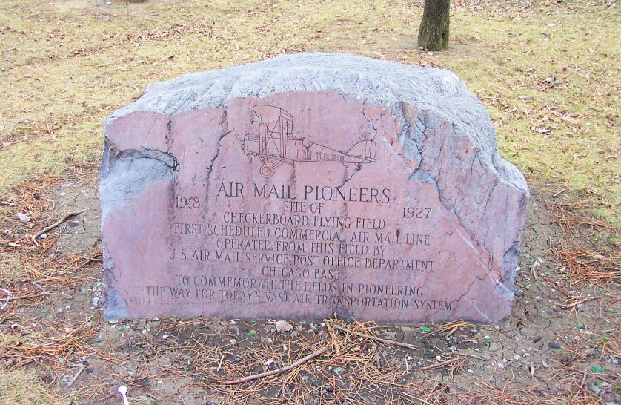
CLE + 314. Lake Calumet. — Largest and most westerly of three lakes. From northern extremity of Lake Calumet fly northwest on compass course of 315˚ Ashburn Field comes into view to the west and a large gas reservoir to the east. A large drainage canal will be seen ahead. To your left, where the Des Plaines River enters the drainage canal, the canal makes a 45˚ turn to the south. Follow the Des Plaines River for about 10 miles and you will see a large hospital and old race track. This is the speedway and adjoins the air-mail field on the west.
CLE + 330. Chicago air-mail field or Checkerboard field. — Three large air-mail hangars in southwest corner of field and private hangar in northeast corner. Four-way field, but best approach from the south. Telephone and high-tension wires to west and wires and trees to east of field. Land on large cinder runways. Sewage-disposal plant with excavations on west side of field. Landing area of this field large and ample. Telegraph and post-office address of this is Maywood, Ill. Field is 14 miles west of Chicago post office.
Four different planes participated in the first day-night transcontinental flight on February 22, 1922 (George Washington’s Birthday after the US adopted the Gregorian calendar in 1752), two each from New York and San Francisco.
Of the two New York-based flights, one was forced down shortly after takeoff and the other landed at Checkerboard, only to be grounded by a snowstorm.
The first pilot from San Francisco crashed and died in Nevada but the second made it to North Plane, Nebraska, where a relay pilot named James H. ("Jack") Knight took over. Knight left North Plane at 7:50PM and arrived at Omaha, Nebraska at 1:15AM, where he found that his relief pilot had been snowed in Chicago and had never made the flight to meet him at Omaha. Knight decided to continue on himself and fly the 435 miles to Chicago despite the fact that the Midwest was getting blasted by the fiercest snowstorm they'd seen in years.
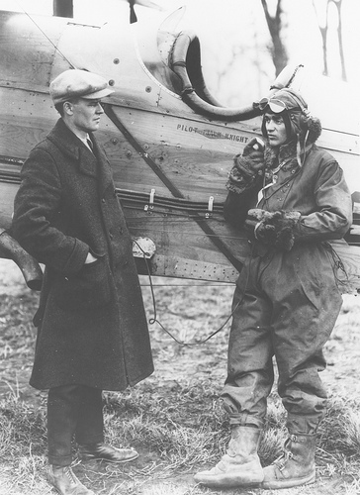
Since the Des Moines refueling stop was also shut down due to the weather. Knight was forced to an alternate site in Iowa City which had also closed down once they had heard that the relay flight from Chicago had been canceled. Fortunately, the Iowa City night watchman was able to guide Knight to a safe landing just as the plane's fuel ran dry.
While his plane was being refueled, Knight ate a donut and drank some coffee. He wasted no time and took off into the driving snow as soon as his plane was ready; he arrived at Checkerboard at 8:40AM, proving once and for all that day-night coast-to-coast service was indeed feasible.
James H. ("Jack") Knight
http://www.franzosenbuschheritageproject.org/Histories/Checkerboard%20Field/Checkerboard%20Air%20Field_expanded%20version.htm

CHICAGO TO IOWA CITY
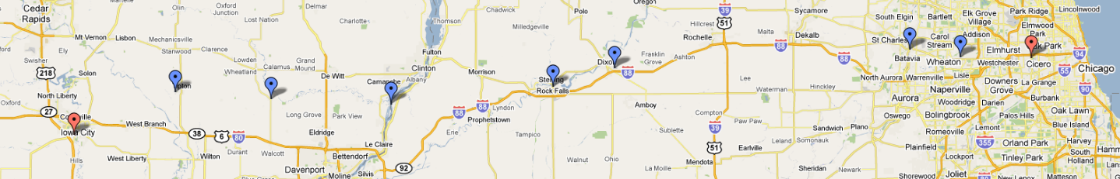
Miles from Chicago
CHI + 0. Maywood, Ill. — Checkerboard field. Fly directly west, picking up the third railroad to the north of the field. This is the Chicago & North Western. By keeping on the section lines and flying directly west this railroad can be kept in sight at all times until Iowa City is reached. It has white ballast and is doubled-tracked.
CHI + 14. Wheaton, Ill. — Directly on course. Town rests in elongated U formed by Chicago & North Western Railroad. Water tower serves as a landmark.
CHI + 24. Geneva, Ill on the Fox River. — One mile north of course. Two branches of the Chicago & North Western cross each other here at right angles.
CHI + 84. Dixon, Ill. — Three miles north of course on Rock River.
CHI + 96. Twin Cities of Stirling and Rock Falls. — One on each side of the Rock River.
CHI + 130. Mississippi River. — The Mississippi River should be crossed about 6 miles below Clinton, Iowa, which is on the west bank of the Mississippi. Flying in the same direction, the Wapsipinacan [Wapsipinicon] River will show up soon after crossing the Mississippi. The Wapsipinacan empties into the Mississippi a few miles south of the course. Fly in the same general direction with this river in view for 24 miles. The Chicago, Rock Island & Pacific runs in the same general direction as this river and is never more than 3 miles from it until Dixon, Iowa, is reached.
CHI + 154. Dixon, Iowa. — One mile north of the course and 1 mile west of the Wapsipinacan River, which turns north at this point. Dixon lies between the Chicago, Rock Island & Pacific and the C. N. W. & St. P., which cross about 1 mile east of Dixon.
CHI + 173. Tipton, Iowa. — Five miles north of the course. Soon after Tipton is reached, Cedar Rapids will be crossed. The Cedar River flows southeast at this point.
CHI + 191. Iowa City, Iowa. — On the eastern bank of the Iowa River. The Chicago Rock Island & Pacific has four lines running out of Iowa City. The air-mail field is south of town and on the western bank of the river. The field is small and is longer east and west.

IOWA CITY TO OMAHA
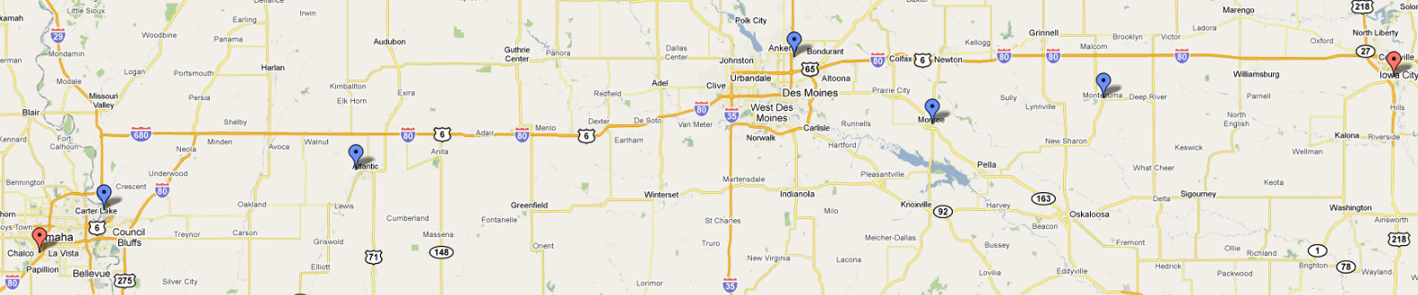
Miles from Chicago
CHI + 191. Iowa City, Iowa. — On the eastern bank of the Iowa River. The Chicago Rock Island & Pacific has four lines running out of Iowa City. The air-mail field is south of town and on the western bank of the river. The field is small and is longer east and west.
CHI + 215. Chicago, Milwaukee & St. Paul Railway.
CHI + 233. Chicago & North Western Railway.
CHI + 240. Montezuma. — Directly on course on Minneapolis & St. Louis Railway.
CHI + 249. Minneapolis & St. Louis Railway.
CHI + 253. Minneapolis & St. Louis Railway. — Short line.
CHI + 255. Minneapolis & St. Louis Railway.
CHI + 271. Monroe. — Slightly south of course on Chicago, Rock Island & Pacific Railroad. Three lines out of this town.
CHI + 296. Des Moines. — Five miles north of course. Largest city near course between Iowa City and Omaha. Keep the Raccoon River in sight until about 18 miles out. From here on keep the Chicago, Rock Island & Pacific in sight. This railroad follows the direction of the Raccoon River for this distance. The Chicago, Rock Island & Pacific is 2 to 7 miles north of the course.
CHI + 368. Atlantic, Iowa. — Three miles north of the course on the Chicago, Rock Island & Pacific Railway. At Atlantic the railroads branch in five directions. If on the course at this point, that is, 3 miles south of Atlantic, fly nearly due west until Council Bluffs is seen.
CHI + 413. Council Bluffs, Iowa. — Five miles east of the Missouri River.
CHI + 418. Missouri River, which is very irregular in its course and width at this point.
CHI + 424. Omaha, Nebr. — Field is west of city and can be identified by large hangar with white circle and cross on roof. North of field is large race track and grandstand. There are two good approaches, from north and west.

OMAHA TO NORTH PLATTE
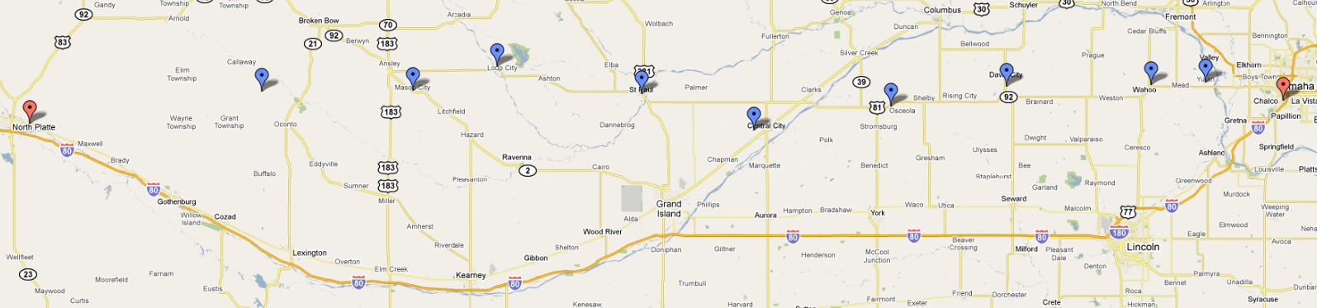
Miles from Omaha
OMA + 0. Omaha, Nebr. — The air mail field is on the western outskirts of the city, and is 5 miles west of the Missouri River. The field is rectangular, the long way of the rectangle being east and west. On the north side of the field is a long grand stand facing northward and extending east and west. To the north of the grand stand is a large field with an elliptical race track in it This race track is an excellent landmark, and the oval may be used for landing if necessary. The west side of the mail field is bounded by a brook, a few trees, and a railroad track. On the south the field is bounded by a paved road which ends to the eastward at the Missouri River. This same road runs due west for several miles beyond the mail field. On the south side of the field are some high trees and a few telephone poles. A private hangar is situated across the road from the air mail field with the word “Airdrome” painted on the roof. The air mail hangar is located in the southeast corner of the field. The east side of the field is bounded by two steel wireless towers and a hill covered with high trees. From the northwest is the best approach, although landings can be made from any direction if made into the wind.
OMA + 20. The Platte River is crossed at right angles by flying due west from the Omaha field. By noting section lines the pilot can determine the correct compass course correcting for drift, as North Platte and Cheyenne are almost due west of Omaha. For a distance of 70 miles the Platte River is north of the course never at a greater distance than 10 miles. The Platte River should be crossed between two bridges, one 2 miles north and the other 2 miles south of the course.
OMA + 21. Yutan. — Directly on the course 1 mile west of the Platte River, 5 lines of railroads form a junction at this point.
OMA + 33. Wahoo. — A fair-sized town 3 miles south of the course. Six railroads radiate from Wahoo. An excellent emergency landing field is located one-half mile south of Wahoo; a smooth barley field approximately 1 mile long and a quarter of a mile wide. By noting section lines and flying 25 miles west for each mile south, a direct course may be maintained.
OMA + 59. David City. — A quarter of a mile north of the course. Six railroads radiate from this city also.
OMA + 82. Osceola. — Four miles south of the course. The Union Pacific tracks almost parallel the course from David City to Osceola, where they turn to the southward. Osceola may be identified by a mile race track just south of the town.
OMA + 96. The Platte River is crossed again and runs southwestward. The Union Pacific Railroad is crossed just beyond the Platte River a half a mile north of the small town of Clarks. Twelve miles southwest is Central City on the Union Pacific Railroad. This city is 7 miles south of the course. Central City is directly east of North Platte. If the pilot passes directly over this city, the east-west section lines can be followed directly into North Platte. Thirty-five miles southwest of Clarks is Grand Island in a direct line with Central City. Grand Island is 20 miles south of the course. At Grand Island there is a commercial flying field where supplies of oil and gas may be purchased.
OMA + 132. St. Paul, directly on the course. — Ten miles east of St. Paul one branch of the Chicago, Burlington & Quincy Railroad runs directly west to St. Paul and lies on the course. Five railroads radiate out of St. Paul. The Middle Loup River is crossed 1 mile east of St. Paul.
OMA + 161. Loup City. — Is 5 miles north of the course on the east bank of Middle Loup River, which is crossed almost due south of Loup City. The Union Pacific Railroad paralleling the river is crossed 1 mile east of the river.
OMA + 176. The Chicago, Burlington & Quincy Railroad tracks following a tiny stream are crossed. The railroad runs northwest-southeast at this point.
OMA + 183. Mason City. — On the Chicago, Burlington & Quincy Railroad; is 2 miles north of the course.
OMA + 216. The Union Pacific Railroad, running northeast-southwest, is crossed midway between Lodi and Oconto; Lodi to the north and Oconto to the south. A small creek runs through Oconto which distinguishes it from Lodi.
OMA + 248. North Platte. — After crossing the Union Pacific Railroad no distinguishing landmarks are available, but flying west the Platte River will be seen to the south, gradually getting nearer to the course. The city of North Platte is located at the junction of the north and south branches of the Platte River. The field is located on the east bank of the north branch about 2 ½ miles east of the town, just 100 yards south of the Lincoln Highway Bridge. Another bridge, the Union Pacific Railroad bridge, crosses the stream a mile farther north. The field is triangular with the hangar at the apex of the triangle and on the bank of the river. The field, which is bounded on the southwest by the river bank and on the north side by a ditch, has an excellent turf covered surface always in a dry condition. The field is longer east and west and the best approach is from the end away from the hangar. Cross field landings should not be attempted near the hangar, as the field is narrow at this point. The altitude of North Platte is 2,800 feet or about 2,000 feet higher than the Omaha field.

NORTH PLATTE TO CHEYENNE
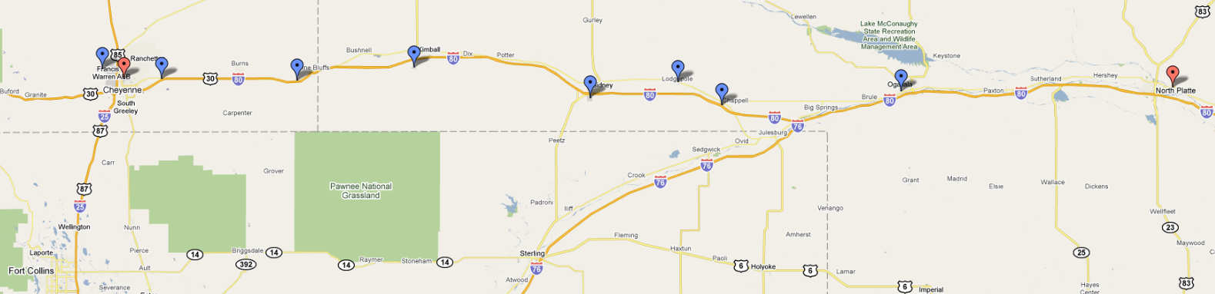
Miles from Omaha
OMA + 248. North Platte
OMA + 298. Ogallala. — The south branch of the Platte River parallels the course to this point and the north branch is only a mile or two north of the course, veering gradually to the northward. The double tracks of the Union Pacific Railroad follow the course to this point. Fly directly west from this point, the south branch of the Platte River and the Union Pacific Railroad, veering to the southward.
OMA + 338. Chappell. — Two miles south of the course on the Union Pacific tracks and on the north bank of the Lodgepole Creek.
OMA + 342. Lodgepole. — Directly on the course between the Union Pacific Railroad and Lodgepole Creek. From here on to Sidney the course lies over the Union Pacific Railroad tracks and Lodgepole Creek.
OMA + 360. Sidney. — The Union Pacific double track runs through here east and west, crossed at right angles by the Chicago, Burlington & Quincy Railroad running north and south. Two miles west of Sidney the Union Pacific double track veers to the north, following the course of the Lodgepole Creek. The course, due west, lies from 4 to 6 miles south of the railroad and creek for the next 60 miles.
OMA + 395. Kimball. — Five miles north of the course on the Union Pacific Railroad and Lodgepole Creek.
OMA + 420. Pine Bluff, Wyo. — On the Union Pacific Railroad 2 miles north of the course. The railroad and creek again cross the course, the railroad, turning westward to Cheyenne and the creek, continuing south for 4 miles and then eastward. The country between Sidney and Pine Bluff is the roughest on the whole course from Omaha to Cheyenne, but plenty of emergency fields are found. A ridge extends southward from Pine Bluff, on which numerous dark green trees may be seen. Two miles southwest of Pine Bluff the Union Pacific tracks are crossed and for 5 miles lie south of the course. Then another intersection of the course and the railroad looping to the northward and again crossing the course at the small town of Archer.
OMA + 499. Archer Wyo. — A small town on the Union Pacific Railroad and 8 miles from Cheyenne.

OMA + 458. Cheyenne Wyo. — Can be identified by the barracks of Fort Russell. The Cheyenne field is three-quarters of a mile due north of the town and due north of the capitol building, whose gilded dome is unmistakable. The field, though rolling, is very large and landings may be made from any direction. A pilot landing here for the first time must “watch his step,” as the rarified atmosphere at this altitude (6,100 feet) makes rough landings the rule rather than the exception.

CHEYENNE TO ROCK SPRINGS
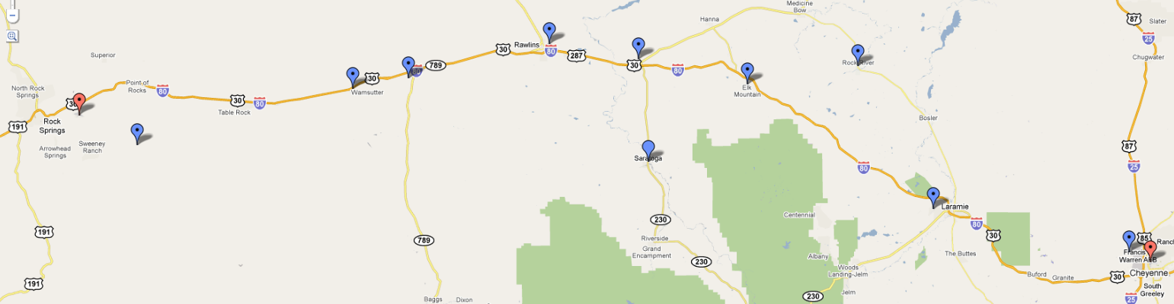
Miles from Cheyenne
CHE + 0. Cheyenne Wyo. — Fly west over or to the north of Fort Russell, which is about 4 miles from town, following the Colorado & Southern tracks to the point where they bend sharply to the north.
CHE + 12. Federal Wyo. — The first town on the Colorado & Southern Railroad after the railroad makes a sharp bend to the north. Fly about 6 miles south of Federal and leave the Colorado & Southern tracks about 1 mile north of the pronounced bend. The compass course, when there is no cross wind, is about 310˚. Cross Sherman Hills or Laramie Mountains at about 9,000 feet above sea level. Crossing this range of mountains the Laramie Valley appears where landing fields abound.
CHE + 40. Laramie Wyo. — On the Union Pacific double-tracked railroad. The largest town in the valley. Pass 6 miles to the north of Laramie.
CHE + 60. Rock River Wyo. — On the Union Pacific, 20 miles north of the course. The double-tracked Union Pacific passes through 2 miles of snow sheds at this point.
CHE + 80. Elk MountainWyo. — To the north of the Medicine Bow Range, a black and white range of mountains, the black parts of which are forests and the white snow-covered rocks. Elk Mountain is 12,500 feet high. Fly to the north of this conspicuous mountain over high, rough country. The Union Pacific tracks will be seen about 15 miles to the north gradually converging with the course.
CHE + 114. Walcott. — Cross the S. & E. Railroad 2 miles south of Walcott. The S. & E. joins the Union Pacific at this point.
CHE + 134. Rawlins Wyo. — Follow the general direction of the Union Pacific tracks to Rawlins, which is on the Union Pacific tracks. The country between Walcott and Rawlins is fairly level, but covered with sage brush, which makes landings dangerous. Rawlins is on the north side of the Union Pacific tracks at a point about a mile east of where the tracks cut through a low ridge of hills. Large railroad shops distinguish the town. The emergency field provided here lies about 1¼ miles northeast of town at the base of a large hill. Landings are made almost invariably to the west. Surface of field is fairly good, as the sage brush has been removed. Easily identified by this, as the surrounding country is covered with sage brush. Landings can be made in any direction into the wind if care is exercised. Several ranch buildings and two small black shacks on the eastern side of the field help distinguish it. Leaving Rawlins follow the Union Pacific tracks to Creston.
CHE + 159. Creston Wyo. — A small station on the Union Pacific is the point where the course crosses the Continental Divide.
CHE + 175. Wamsutter, Wyo. — On the Union Pacific. Fairly good fields are found between Rawlins and a point 60 miles west. Fields safe to land in show up on account of the absence of sage brush. The course leaves the railroad where the Union Pacific tracks loop to the southeast.
CHE + 215. Black Butte. — A huge black hill of rock south of the course. The Union Pacific Railroad is crossed just before reaching Black Butte.
CHE + 231. Rock Springs, Wyo. — After passing Black Butte, Pilot Butte will be seen projecting above and forming a part of the Table Mountain Range. This butte is of whitish stone. Head directly toward Pilot Butte and Rock Springs will be passed on the northern side. The field is in the valley at the foot of Pilot Butte about 4 miles from Rock Springs. It is triangular in shape, the hangar being located in the apex. The surface of the field is good. The best approach is from the eastern side.

ROCK SPRINGS TO SALT LAKE CITY
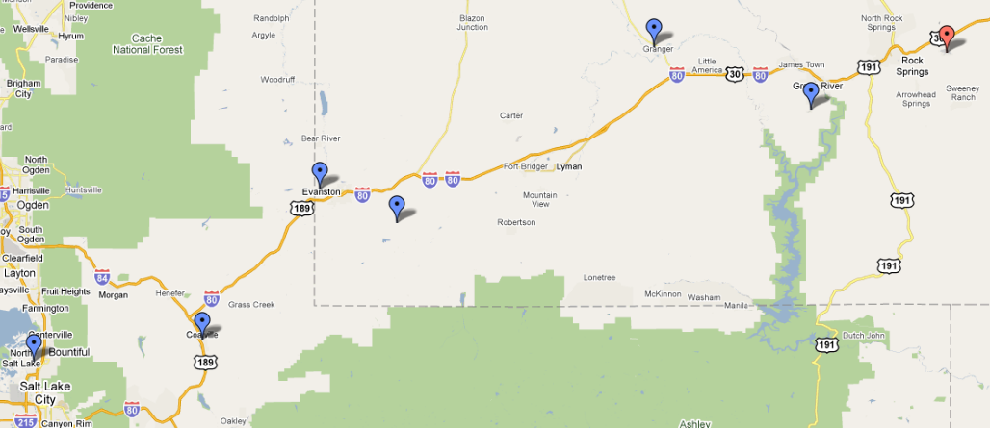
Miles from Cheyenne
CHE + 231. Rock Springs
CHE + 246. Green River, Wyo. — Follow the Union Pacific double-tracked railroad from Rock Springs. There is an emergency field here which is distinguished [on] account of its being the only cleared space of its size, near the town. Green river is crossed immediately after the city of Green River is passed. Here the course leaves the railroad which continues in a northwesterly direction. By flying approximately 230˚ compass course from here, Cheyenne [Salt Lake City] will be reached.
CHE + 258. Black Fork River. — A very irregular river, which is crossed at right angles. From Black Fork to Coalville the Union Pacific tracks are from 5 to 20 miles north of the course.
CHE + 282. Granger, Wyo. — 16 miles north of the course on the Union Pacific where the Oregon Short Line joins the Union Pacific from the north.
CHE + 330. Altamont, Wyo. — On the Union Pacific where the Union Pacific approaches within 6 miles of the course to the north. The railroad passes through a short tunnel at this point.
CHE + 338. Evanston, Wyo. — After approaching within 6 miles of the course, the railroad turns sharply to the northwest. Evanston is on the Union Pacific 18 miles north of the course. There is a good emergency landing field on the southwest side of Evanston, a mile from the railroad station. From Evanston the Union Pacific tracks curve toward the course until Coalville is reached.
CHE + 363. Coalville, Utah. — On the single track Union Pacific running north and south. The single track Union Pacific joins the double track 4 miles north of Coalville at Echo City. There is an emergency landing field here a mile east of the railroad and one-half mile southeast of town. There is a marker on this field.
CHE + 381. Salt Lake City. — From Coalville the country is extremely rugged and the pilot should maintain at least 11,000 feet altitude above sea level. The field lies 2 miles west of the city on the north side of the road or street which extends east-west by the Salt Lake fair grounds. Locate the fair grounds, identified by an elliptical race track and large buildings. Follow westward along the road just south of the fair grounds and the field will be reached 1 ½ miles farther on. The field is about one-half mile long north and south and landings are usually made in one of these directions. A landing T is used to indicate the proper place to land. Elevation here is 4,400 feet. High-tension wires border all sides of the field except the north.

SALT LAKE CITY TO RENO
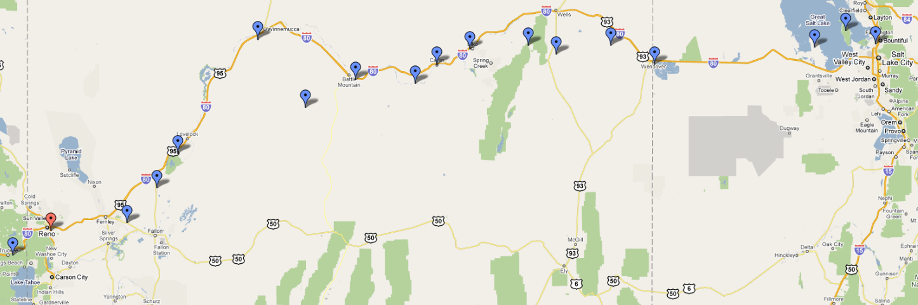
Miles from Salt Lake City
SLC + 0. Salt Lake City. — Fly west from Salt Lake, keeping the two railroads running due west from Salt Lake to the south.
SLC + 12. Saltair. — Near the salt works there is an open field which is possible for an emergency landing. The field lies between the highway and the electric railroad that runs into Salt Lake City. Is rolling and covered sparsely with sagebrush and should be used only in case of absolute emergency.
SLC + 14. Antelope Island. — In the Great Salt Lake, 6 miles north of the course.
SLC + 30. Stansbury Island. — In the Great Salt Lake. The course crosses this island about 2 miles from its southern edge.
SLC + 45. The Union Pacific Railroad is crossed where it runs northeast-southwest. Two miles north of the course the railroad makes a sharp bend and runs southeast-northwest.
SLC + 50. The Union Pacific Railroad is crossed again. The Union Pacific continues southeast from here for 10 miles and then turns westward and parallels the course to Wendover. The course is 6 miles north of the railroad.
SLC + 98. Salduro. — On the Union Pacific Railroad, 6 miles south of the course. There is an emergency field here in vat No. 5, marked by a black T. The vat is circular, 400 feet in diameter and the bottom, composed of white salt, is hard as a pavement.
SLC + 108. Wendover. — On the Union Pacific, 6 miles south of the course. Opposite the Conley Hotel and the Union Pacific station there is a landing field L-shaped, 1,200 feet long each way and 600 feet wide, a good emergency field. Four miles west of Wendover the Union Pacific Railroad turns to the north and east and is crossed 8 miles west of Wendover. The railroad continues northwestward and reaches a northern point 11 miles from the course. The railroad curves and runs southeast, where it crosses the Nevada Northern, running north-south at Shafter.
SLC + 130. Shafter. — At the junction of the Nevada Northern and Western Pacific Railroads. Opposite the Western Pacific station at Shafter there is a stretch of ground 1,200 feet wide and unlimited in extent the long way, that may be used for emergency landings. There is a scattering of sagebrush on this field.
SLC + 145. The Western Pacific Railroad is crossed, running northwest-southeast, after it makes a loop to the south just beyond Shafter. The railroad veers to the north until it is 20 miles north of the course.
SLC + 157. Snow Water Lake. — An oblong body of water 3 miles south of the course. The long way of the lake extends parallel to the course.
SLC + 170. Secret Pass in the East Humboldt Range. — The only pass in this range for many miles. Some peaks in this range attain an altitude of more than 12,000 feet. The northern extremity of the Ruby Range extending north and south lies a few miles south of the course and is next seen. Then three branches of Tamoville Creek flowing north to the east fork of the Humboldt River are crossed at short intervals. The Southern Pacific and Western Pacific Railroads follow the course of the east fork of the Humboldt River and gradually converge on the course where all four join at Elko.
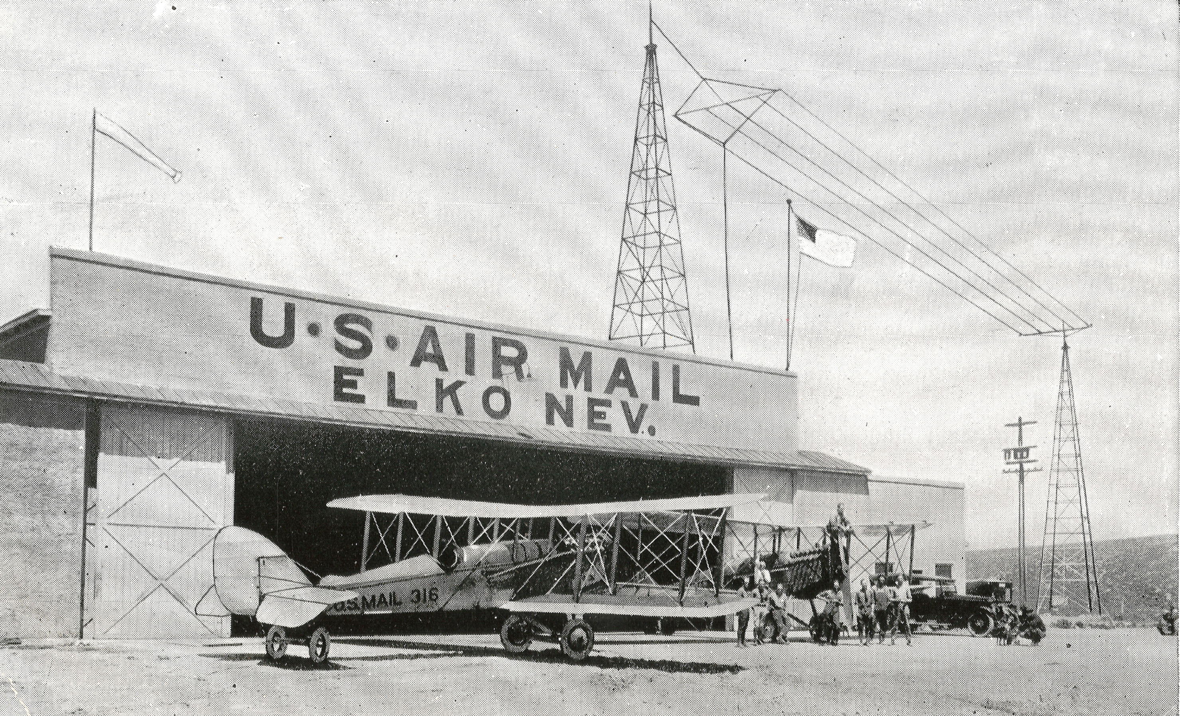
SLC + 204. Elko, Nev. — Lies in the Humboldt Valley. The air mail field is 1 mile west of the city, with the main runway east and west. Landings may be made from any direction, although it is advisable to land east and west. There is a ditch at the east end of the field. Follow the general direction of the railroad tracks out of Elko, as they run parallel with the course for several miles.
SLC + 224. Carlin, Nev. — Between the Western Pacific and the Southern Pacific Railroad tracks, 1 mile south of the course.
SLC + 238. Harney. — Six miles south of the course, midway between the cities of Palisade and Beowawe on the Southern Pacific and Western Pacific Railroads. South of the railroad tracks here is an emergency field 1,500 by 900 feet, with a shallow ditch in the center running across. Landings can be made safely across this ditch. There is a ranch house in one corner of the field. A narrow gauge railroad runs south from Palisade, a town 7 miles east of Harney.
SLC + 246. The course crosses the Western Pacific and Southern Pacific Railroad tracks. Up to this time the railroad tracks have been on the south of the course, but from now on the two railroads are to the north.
SLC + 268. Battle Mountain. — At the junction of the Southern Pacific and the Nevada Central Railroads, 8 miles north of the course. Battle Mountain lies in a valley surrounded on the east and west by high ranges. Here will be found an excellent landing field laid out in the form of an ellipse, marked with a T and a wind-indicator. The field lies directly west of town. All types of supplies for servicing may be found here. From this point the railroads turn north and west and leave the course almost at right angles.
SLC + 278. The Nevada Central Railroad is crossed 12 miles southwest of Battle Mountain. From here on for the next 100 miles the course lies over uninhabited and desert country.
SLC + 293. Alkali Lake. — Lies on the northern edge of the course.
SLC + 363. Humboldt Lake. — The course adjoins the southern edge of this lake and crosses the Southern Pacific Railroad 5 miles beyond. If the pilot elects to not fly the direct course, the Southern Pacific Railroad may be followed from Battle Mountain to Winnemucca, a distance of approximately 60 miles. At Winnemucca is an emergency field south of town, marked by a wind indicator and a T. Supplies necessary for servicing a ship may be obtained here. At this point the Western Pacific continues on in a westward direction, while the Southern Pacific turns to the southwest. Following the Southern Pacific for 30 miles the small town of Imlay will be reached. There is open unobstructed land on all sides of the town, suitable for emergency landings. Forty miles farther on will be found the city of Lovelocks. A first-class landing field is situated here on the eastern edge of the Southern Pacific tracks just south of town. A permanent T has been placed on the field and a rolled runway constructed. Gas and oil may be obtained from the Standard Oil plant on the edge of the filed, and at a near-by fertilizer plant there is a fully-equipped machine shop which is offered for the use of any pilot who may need to make repairs to his ship. This field is level and is kept up in good shape. Pilots coming in must hold the ship up with the gun until they pass over a series of irrigation ditches at the end of the field. After these ditches have been passed a landing may be made. Numerous emergency landing fields may be found all the way between Winnemucca and Lovelocks. Twenty-five miles farther on the Southern Pacific joins the course 5 miles east of the southern edge of Humboldt Lake, into which the Humboldt River empties. To the south of Lake Humboldt is Carson Sink, which has a dry sandy bottom throughout the year and offers an ideal landing ground, but is uninhabited and pilots can not receive assistance except along the railroad. By following the Southern Pacific Railroad from Humboldt Lake southward for 25 miles, Hazen, Nev., will be reached.
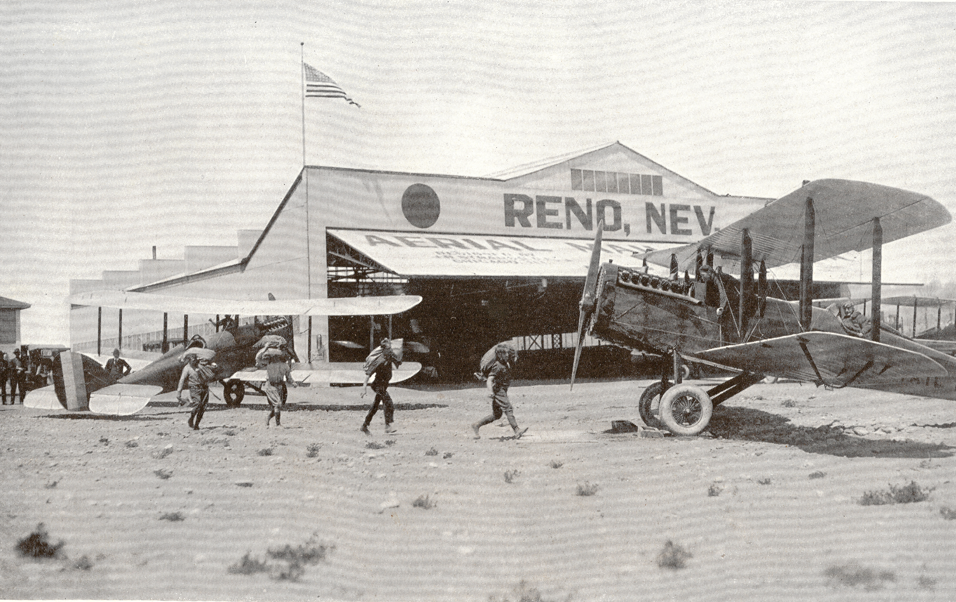
SLC + 388. Hazen, Nev. — Fourteen miles south of the course on the Southern Pacific Railroad. Four branches of this railroad radiate out of Hazen. All about the town there are open fields of a size sufficient to set down an airplane. The best landing field is to the south and east of the Southern Pacific roundhouse and is a space a mile long and half a mile wide. Sagebrush grows on the eastern portion of this field and the southern end is bounded by a set of high-tension wires. A 40-foot T marks the field. If the pilot has flow as far south as Hazen he can follow the Southern Pacific westward into Reno. If he is on the direct course, he will cross the northern branch of the Southern Pacific 7 miles north of where it joins the east-west main line at Fernley. Twelve miles to the north Pyramid Lake can be seen.
SLC + 437. Reno, Nev. — The air mail field at Reno lies 2 miles west of the city. The main runway is east and west. The field is marked by a T and wind indicator, and landing from four ways is unobstructed. Reno is 4,497 feet above sea level. Whenever possible it is advisable to leave the Reno field on the east-west runway, taking off to the east. A slight downgrade enables the ship to quickly obtain flying speed. Just beyond the east edge of the field the ground is extremely rough and there is a huge ditch here.

RENO TO SAN FRANCISCO
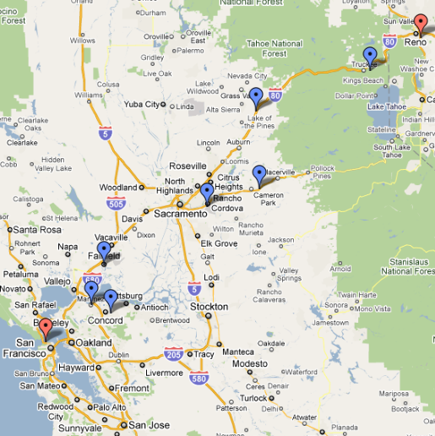
Miles from Reno
REN + 0. Leaving the Reno field the pilot should head his ship southwest and gain altitude of at least 10,000 feet to pass safely over the Sierras. Practically all of this altitude should be obtained near the field before starting on the course.
REN + 020. Lake Tahoe. — The northern edge of Lake Tahoe is 6 miles south of the course.

REN + 025. Truckee. — On the Southern Pacific near the point where Lake Tahoe Railway joins the Southern Pacific from the south. Two and a half miles to the northwest of Truckee lies a very good summertime emergency landing field. All approaches are clear and a space available for a landing 600 by 2,000 feet. A big boulder painted white stands on the northwest side of the field and beside it is a white wind indicator. This field is to be avoided in winter, as snow gathers on it to a frequent depth of 4 feet. Soon after passing Truckee the Sierras are crossed. On the direct course 10,000 feet will clear the highest peak, but an altitude of 15,000 feet should be maintained. The Southern Pacific Railroad tracks veer to the west and north and from here on to Sacramento are at a varying distance of 5 to 20 miles north and west of the course.
REN + 065. Colfax. — Seventeen miles northwest of the course on the Southern Pacific Railroad. Elevation here is 2,422 feet. A small level field lies one-half mile south of the city. The field should be used only in an emergency, as it is difficult to get into and during the rainy season is very soft. The field is 600 by 300 feet.
REN + 085. Shingle Springs. — Seven miles south and east of the course, on the Placerville Branch of the Southern Pacific that runs from Placerville to Sacramento. There is a field here one-half mile west of Shingle Springs, bounded on the north by a highway running to Placerville and on the south by the Southern Pacific tracks. The field is 1,500 yards long north and south and 300 yards wide east and west. The ground is level, hard, and smooth. The elevation here is approximately 1,000 feet.
REN + 095. The Southern Pacific, running from Placerville to Sacramento, is crossed at right angles 1 mile southeast of where it makes a right-angular bend and approximately parallels the course for the next 15 miles. The course lies from 1 to 3 miles southeast of this track.
REN + 0112. Mather Field. — Is the Army Air Service station in the Sacramento Valley, equipped like all Air Service flying fields. It is located to the east of Sacramento and near the small siding called Mills, 2 miles north and east of the course. A huge white water tower serves as an excellent landmark as well as the three lines of buildings on the ground. Three railroads are crossed in a stretch of less than 10 miles soon after leaving Mather Field. The Southern Pacific Railroad is to the northeast of the course at a varying distance of 10 to 15 miles after leaving Mather Field. Southwest of the course the Sacramento River will be seen soon after crossing the three railroad tracks at a distance of 5 to 10 miles.
REN + 0152. Suison [Suisun] Bay. — Into which the Sacramento River empties, a large oblong body of water parallel to the course. The pilot will fly along the southwest side of this bay.
REN + 0162. Martinez. — On the southeast corner of Suison bay. One mile northwest of the course.
REN + 0177. Durant Field, Oakland, Calif. — On the eastern side of San Francisco Bay. The field runs almost due east and west and has a hangar, wind indicator, and T laid out on it. By coming in from the east over the hangar an unobstructed run of about 2,000 feet is obtained. North and south the field is rather narrow and somewhat rough. All supplies necessary for reservicing a ship may be obtained here. From here fly directly across San Francisco Bay. The course goes directly over Alcatraz Island, covered with white Government buildings. Goat Island, larger than Alcatraz, and more irregularly shaped, on which is located the Naval Station to be seen to the south.
REN + 0187. Marina Field. — Is stationed on the south of San Francisco Bay, 3 miles from the Golden Gate, on the east portion of the old fair grounds. It can be identified by the Palace of Fine Arts Building, which has a large dome roof, at the west end of the field; a monument 150 feet high, the Column of Progress, is on the north side of the field. The city of San Francisco is to the south. There is a prevailing southwest wind here. A double line of wires borders the eastern edge of the field and this, in conjunction with the gas plant in the same vicinity, force the pilot to come in high. The pilot should hold the ship off until the runway is reached coming in either direction, as both the east and west edges of the field are very rough. Landings should not be attempted from any direction other than the east and west.
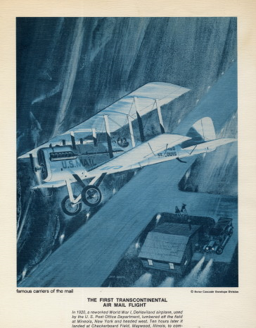
The Post Office Flies the Mail, 1918-1924
On August 12, 1918, the Post Office Department took over airmail service from the U.S. Army Air Service (USAAS). Assistant Postmaster General Otto Praeger appointed Benjamin B. Lipsner, who left the USAAS, to head the civilian-operated Air Mail Service. He would remain only until December 6, when he resigned over what he felt were wasteful and “unnecessary expenditures.” One of Lipsner's first acts was to hire four pilots, each with at least 1,000 hours flying experience, paying them an average of $4,000 per year. The department also abandoned the polo grounds in Washington, D.C., and moved north to the larger airfield at College Park, Maryland, where it would begin its route to Philadelphia.
The department used mostly World War I surplus de Havilland DH-4 aircraft, which were flimsy and not designed for long cross-country flights. Another popular plane was the Standard Aircraft Company JR-1B, which could carry 300 pounds (136 kilograms) of mail as well as 60 gallons (227 liters) of fuel. During 1918, including the initial four pilots, the Post Office hired 40 pilots, and by 1920, they had delivered 49 million letters. In its first year of operation, the Post Office completed 1,208 airmail flights with 90 forced landings. Of those, 53 were due to weather and 37 to engine failure. The Post Office also bought the German-made Junkers F 13, which it renamed the J.L.6 after John Larsen, who had imported it to the United States. The postal service had high hopes for this all-metal plane, but it proved extremely dangerous and was removed from service after several pilots were killed in fiery crashes.
Postal aircraft could fly with sacks of mail for an average cost of $64.80 for each hour in the air. Pilots received a base pay of about $3,600 per year and then were paid five to seven cents more for each mile they flew, flying an average of five to six hours each day. After a year in operation, postal revenues for the year totaled $162,000. The cost to fly the mail had been just $143,000. This first year of operation was to be the only time in airmail history that the service showed a profit.
The largest airmail customers were in the banking business. They used the service to send checks and financial papers more quickly. Bankers wanted to reduce the float time of checks and pushed for an extension of routes. Financial papers were light, and the cost to send them was low—just 16 cents an ounce, having been reduced from 24 cents in July 1918 to attract more customers. It was further reduced to six cents per ounce on December 15, in an effort to draw even more customers. In July 1919, the extra charge for airmail was eliminated completely and airplanes began to carry a random selection of mail. The charge would be reinstated in 1924 when regular transcontinental service began.
International airmail delivery began on March 3, 1919, when Bill Boeing and Eddie Hubbard carried 60 letters from Vancouver, Canada, to Seattle, Washington, in a Boeing Model C. Later that year, Hubbard began flying a Boeing B-1 flying boat for airmail delivery between Seattle and Victoria, British Columbia. He would continue flying the plane for eight years—amassing more than 350,000 miles (563,270 kilometers).
Flying conditions were poor, and the pilots were forced to fly in all kinds of weather. Praeger, who didn't know how to fly, was unyielding about keeping the mail on schedule in spite of the risk, hoping that it would make the public trust the service more. Tragically, of the 40 pilots hired when the Post Office took over airmail operations, at least half had died by 1920, most from weather-related crashes.
In July 1919, pilot Leon Smith refused to fly the mail from New York to Washington, D.C., because of rain, clouds, and visibility of only 200 feet (61 meters). Praeger ordered him to make the trip anyway, using only his magnetic compass to navigate. Smith and his fellow pilot E. Hamilton “Ham” Lee refused to fly in the dangerous weather. Both pilots were fired and then, all the pilots in the airmail system went on strike. After three days of talks, the pilots and managers agreed to require field managers to make a flight check in bad weather. The field managers could either fly the inspection themselves or if they were not pilots, could sit in the mail bin in front of the pilot. The flight would continue only if the field manager said weather conditions were safe for flying.
Postal planes began flying across the country on September 8, 1920. But these flights took place only in daylight because pilots relied on visual landmarks to navigate. Each night, the mail would be loaded onto railcars and would travel overnight until daylight allowed another plane to take over. Rugged terrain and poor weather, especially in the West, combined with unreliable planes to slow the service. The service was criticized for being uneconomical and unsafe. Praeger decided to demonstrate how far airmail had come by flying across the country by day and by night. On February 22, 1921, pilot Jack Knight helped to change the mix of railroads and aircraft and give airmail service more status during a test of transcontinental airmail.
As part of a relay team of pilots from San Francisco to New York, Knight was scheduled to carry the mail only part of the way, but a snowstorm in Chicago delayed all the other pilots. Knight flew the mail from North Platte, Nebraska, all the way to Chicago, though normally other pilots waiting at stations would have split the trip. Much of Knight's flying was by night in the bitter cold. He found his way by looking for bonfires and flares lit by helpers on the ground. After 830 miles (1328 kilometers), Knight finally connected with his relief pilot in Chicago. When the last man in the relay reached New York, the total time to carry the mail had been 33 hours 20 minutes—compared to four and a half days by train. This was Praeger's final triumph before he was replaced in April when the administration changed.
Progress continued to be made. By November 1921, 10 radio stations were installed along the New York-San Francisco routes to transmit weather forecasts. Soon, parachute flares were installed in the undercarriage of aircraft to light emergency fields. Flashing beacon lamps or searchlights were mounted on towers all across the United States 10 to 30 miles (16 to 48 kilometers) apart depending on the terrain. Most pilots still flew about 200 to 500 feet (60 to 152 meters) above ground level so they could navigate by roads and railways. By the end of 1921, 98 airmail planes were in service. In 1922, Tex Marshall helped form the Air Mail Pilots Association and became its president. On July 16, 1922, the Air Mail Service could brag that it had completed one year of flying without a fatal accident. In February 1923, the service was awarded the Collier Trophy for its achievements.
Regularly scheduled transcontinental service began on July 1, 1924, using pilots leaving from both the East and West coasts. The pilots also began regular night flights. They were guided by a lighted transcontinental airway with rotating beacons and brightly lit emergency landing fields along the way, and they timed their night flying so as to reach the end of the lighted airway by daybreak. They tested the new gyroscopic needle to indicate whether aircraft wings were level and altimeters to show if the aircraft was climbing or descending. The Post Office resumed using special airmail postage, which it had discontinued in 1919. Airmail now cost eight cents to travel in any of the three zones comprising the transcontinental route and could travel all across the country for 24 cents. By the end of 1924, airmail planes were routinely completing the New York to San Francisco route within 34 hours.
Sources:
Bruns, James H. Mail on the Move. Polo, Illinois: Transportation Trails, 1992.
___________. Turk Bird--The High-Flying Life and Times of Eddie Gardner. National Postal Museum, Washington, D.C.: Smithsonian Institution Press, 1998.
Chaikin, Andrew. Air and Space--The National Air and Space Museum Story of Flight. Boston: Bulfinch Press/Little, Brown and Company, 1997.
Christy, Joe, Wells, Alexander T. American Aviation--An Illustrated History. Blue Ridge Summit, Pa.: Tab Books Inc., 1987.
Ethell, Jeffrey L. Smithsonian Frontiers of Flight. Washington, D.C.: Smithsonian Books, New York: Orion Books, 1992.
Jackson, Donald Dale. Flying the Mail. Alexandria, Va.: Time-Life Books, 1982.
Leary, William M. Aerial Pioneers – The U.S. Air Mail Service, 1918-1927. Washington, D.C.: Smithsonian Institution Press, 1985.
Smith, Henry Ladd. Airways: The History of Commercial Aviation in the United States. New York: Russell & Russell, Inc. 1965.

Further Reading:
Boughner, Fred. Airmail Antics. Sidney, Ohio: Amos Press Inc., 1988.
Heppenheimer, T.A. Turbulent Skies; The History of Commercial Aviation. New York: John Wiley & Sons, 1995.
Holmes, Donald B. Airmail, An illustrated History 1793-1981. New York: Clarkson N. Potter Inc., 1981.
Lipsner, Benjamin B. The Airmail Jennies to Jets. As told to Leonard Finley Hiltsd. Chicago: Illinois, Wilcox and Follett Company, 1951.
Shamburger, Page. Tracks Across the Sky. New York: J.B. Lippincott Company, 1964.

http://www.centennialofflight.gov/essay/Government_Role/1918-1924/POL3G8.htm

